Homework report

1. Graph of validation loss over epochs and graph of training loss over epochs

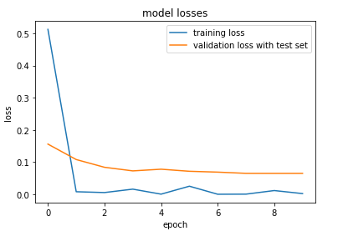

1. Best accuracy obtained as an average over all classes

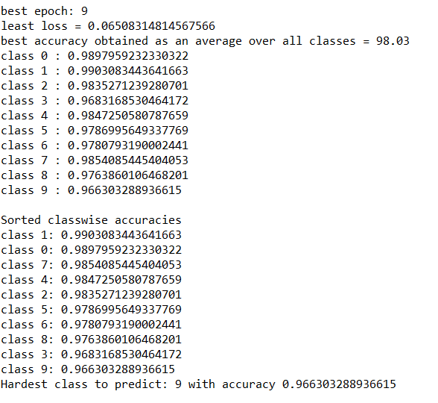

1. Report for the best accuracy ranking of classes by their class-wise accuracies. What is the hardest class to predict?

